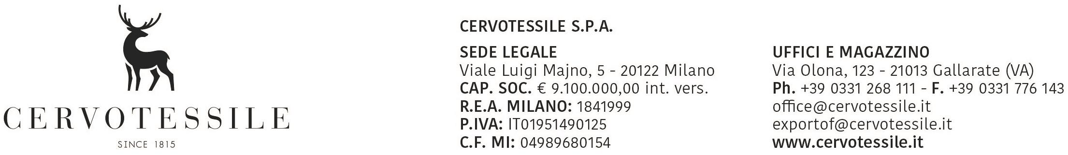

# DECLARATION OF NO SOLID/RAW WOOD PACKING MATERIAL

It is declared that this shipment: ANRAG

ANEST

ANIND + ANIND2 + ANIND3

NZSIGLAIATA, ANLOCALITA

**(Our invoice no. NRFATTURATFT of DATAFATTURATFT)**

Box: NRCOLLI

gross weight kg.: PESO

does not contain solid/raw wood* packing materials.

**CERVOTESSILE SPA**

MARCO PELLEGATTI

________________________________________________

Name of Export Company: Stamp or Signature of Director

Date: DATAFATTURATFT

* If wood is present, this is only “processed wood material” or this is Wood packaging made wholly of wood-based products such as plywood, particle board, oriented strand board or veneer that have been created using glue, heat and pressure or a combination thereof should be considered sufficiently processed to have eliminated the risk associated with the raw wood.