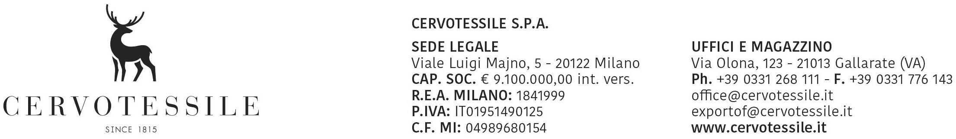

DECLARATION OF NO SOLID/RAW WOOD PACKING MATERIAL

To the Service of China Entry & Exit Inspection and Quarantine

It is declared that this shipment: WAN FUNG GARMENT FACTORY LIMITED
Room 02 , 11/F, Laurels Industrial Centre, 32 Tai Yau Street, San Po Kong
HK - KOWLOON

OUR INVOICE NO. 23013326 31 July 2026

Box: 1
gross weight kg.: 47,85

does not contain solid/raw wood* packing materials.

CERVOTESSILE SPA

MARCO PELLEGATTI
________________________________________________
Name of Export Company: Stamp or Signature of Director

Date 31 July 2026

* If wood is present, this is only “processed wood material” or this is Wood packaging made wholly of wood-based products such as plywood, particle board, oriented strand board or veneer that have been created using glue, heat and pressure or a combination thereof should be considered sufficiently processed to have eliminated the risk associated with the raw wood.

