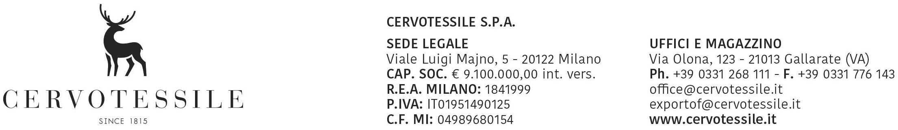

DECLARATION OF NO SOLID/RAW WOOD PACKING MATERIAL

It is declared that this shipment: PAN-KO PANTOLON LTD.
Samandira Cad. No.59 Eyup Sultan Mahallesi
TR – SANCAKTEPE - ISTANBUL

Our invoice no. 23012570 of 29 July 2026

Pallet: 4
gross weight kg.: 3526,00

does not contain solid/raw wood* packing materials.

CERVOTESSILE SPA

MARCO PELLEGATTI
________________________________________________
Name of Export Company: Stamp or Signature of Director

Date: 29 July 2026

* If wood is present, this is only “processed wood material” or this is Wood packaging made wholly of wood-based products such as plywood, particle board, oriented strand board or veneer that have been created using glue, heat and pressure or a combination thereof should be considered sufficiently processed to have eliminated the risk associated with the raw wood.

