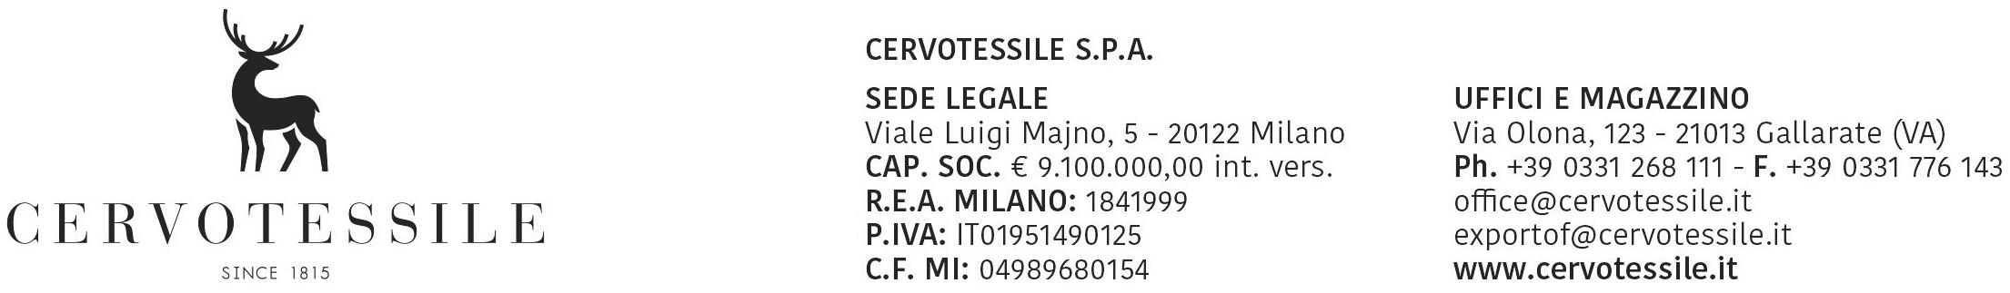

To the courtesy of
Office Customs of
Competence

OBJECT: DECLARATION OF FREE EXPORT

Aware to assume every consequent responsibility, we are to declare that all the material
to we exported with our invoice n. 22007534 of 31/07/2026 with destination AMEREX (MX)

it does not bound to export licences and therefore:

- it’s not included in the directory of the goods as per Regulations (the EEC) n. 428/2009 of
the Council of the 05 Maj 2009, that modificaties and modernizes Regulations (CE)
n. 1183/2007 instituting a communitarian regimen of control of the exports
of products and technologies double use (DUAL USE)

- it’s not included in the directory of the goods as per Regulations (the EEC) n. 338/97 of
the Council of 9 December 1996, related to the protected species of the wild flora
and the fauna controlled by their trade (WASHINGTON CONVENTION - CITES)

- it’s not included in the directory of the goods as per Regulations (the EEC) n. 1523/2007
so it does not contain dog or cat fur (Y922)

- it’s not included in the directory of the goods as per Regulations (the EEC) n. 3911/92 of
the Council of 9 December 1992, relative one to the export of goods of cultural interest

- it’s not included in the directory of the goods as per Regulations (the EEC) n.1236/2005
of the Council of the 27 June 2005, related to the commerce of goods that could be used for the
capital punishment, torture or other cruel treatments or pains, cruel or degrading.

- it’s not included in the directory of the goods as per Regulations (the EEC) n.0423/07
of the Council of the 19/04/2007, concerning restrictive measures to Iran

- it’s not subject to the disposition as per Regulations (the EEC) n.689/2008 of the Council
of the 17/06/2008 related to export of substances chemistries attached I & V

- it’s not subject to the submission of export license for substances that deplete the ozone layer (controlled substances, new substances, equipment and products that depend on these substances) as per Regulations (the EEC) n. 1005/2009 of the Council of 16/09/2009

31/07/2026

