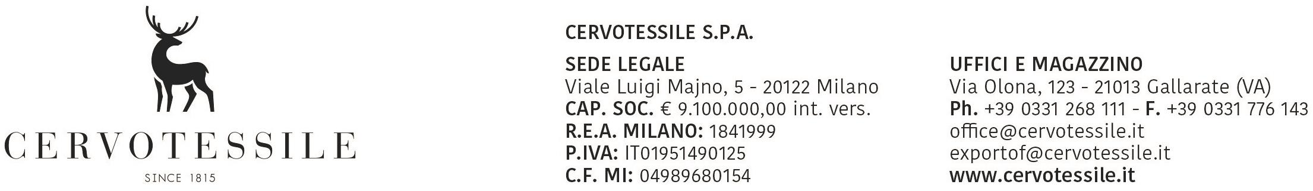

To: Competent custom offices

SUBJECT: DUAL USE

While accepting all consequent responsibilities we do declare that for all the goods listed in export INVOICE nr 20004288 with final destination: **Ukraine**

No export licence is required and therefore:

Goods are not included in the list of products attached to EU Council Regulation (1C) nr. 338/97 about protection of endangered flora and fauna species through trade control.(Washington convention)

-Goods are not included in the list of products attached to EU Council Regulation EU 388/12 which change EU 428/09 and its next modify EU 1232/11, instituting a control system on dual use exports, transfers, brokerage activities or transitory products and technologies, therefore goods are only for civil use.

-Goods are not required of export licence for substances that cause ozone layer reduction (Controlled substances, new substances, praducts and devices d epending on those substances) as provided by EU Council Regulation (EC) nr. 1005/2009.

-Goods are not included in the list of products as per EU Council Regulation (EC) nr. 116/2009, ruling export of cultural goods.

-Giood are not included in the list of products attached to EU Council Regulation (EC) nr. 1236/2005, ruling trade of certain goods that could be used for death penalty, torture or for other cruel, inhuman or demeaning treatments or penalties; goods are not included in other goods listed in TR notes connected to regulation; goods are not included among the ones to be used by civil or military personnel of a member state during an EU or UN peace-keeping operation or crisis management in the third country of destination or during an operation based on agreements between member states or third countries for defence purposes; export to member states overseas territories if goods are used by an authority entitled of law enforcement in the territory or country of destination as well as in the metropolitan territory of the member state to which the territory belongs.

-Goods are not ruled by EU Council Regulation (EC) nr. 1984/03 and 194/08; Refund rate ruled by art. 9 of EU Council Regulation (EC) nr. 612/09; Refund amouni less than 1000,00 € as per art. of EU Council Regulation (EC) sr. 612/09.

«Goods are not ruled by EU Council Regulation (EC) nr. 689/2008 on export of dangerous chemical substances, '

-Goods are not included in the list of goods attached to EU Council Regulation (EC) nr. 117/08 about restrictions versus North Korea, EU Council Regulation (EC) nr. 314/04 about restrictions versus Zimbabwe, EU Council Regulation (EC) nr. 1209/05 about restrictions versus Ivory Coast, EU Council Regulation (EC) nr, 747/09 about restrictions versus Myanmar, EU Council Regulation (EC) nr. 154/09 about restrictions versus Uzbekistan, EU Council Regulation (EC) nr. 1354/05 about restriclions versus Sudan

-Goods are not included in the list of products attached to EU Council Regulation (EC) nr. 1523/2007, therefore do not contain dog and/or cat fur.

-Goods are not included in list of products and-devices containing fluorinated greenhouse gases or depending to those gases to work, as per EU Council Regulation (EC) nr. 842/2006.

-Goads are not ruled by EU Council Regulation (EC) nr. 1005/08 instituting rules to prevent, discourage and eliminate illegal] ,

not declared and not ruled fishing activities. Goods that are not included in the list of products as provided by EU Council Regulation n. 1332/2013 (GU UE L 335)

-Goads are not ruled by EU Cowmcil Regulation (EU) n. 833/2014, annex II, concerning restrietive measures in view of Russia?s actions destabilizing the situation in Ukraine,

-It is not destinated to companies that include in their structure the subjects included in the lists of REGULATIONS (LU ) 208 | 2014 of the Council 0f03,05,2014, n. 269/2014 ofthe Council 003,17.2014, # 38] /2014 ofthe Council of 0414.2014